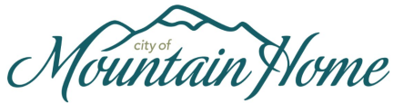

Seeking applications for the position of:

**Library Services Specialist (Part Time)**

Open Date: December 10th, 2024 Closing Date: January 10th, 2024

**Rate of pay: $16.41 per hour, limited to 19.5 hours per week**

**QUALIFICATIONS:**

• Graduation from high school or possession of a GED; and

• Any equivalent combination of experience and training which provides the knowledge, skills, and abilities necessary to perform the work.

**General Statement of Duties:** A Library Services Specialist (grade 3) provides customer service and assistance to library guests regarding library services, programs, and resources. This is a part time position with no benefits afforded. Work hours are capped at 19.5 per week. **Please note**—Saturdays and evening shifts may be a regular part of the work schedule.

**Required Knowledge, Skills & Abilities:**

**Knowledge of:**

• Customer service skills needed to create a positive experience for guests

• A basic understanding of adult and children’s literature

• Effective communication skills

**Ability to:**

**•** Learn Library circulation operations, including automated circulation systems

• Sort, shelve, and organize books and other library media

• Assist library guests with various technology offerings (computers, ebook readers, digital services)

• Provide circulation desk coverage

• Assist with preparation/presentation of adult and juvenile programming and events

• Work a flexible schedule

**Other Requirements:**

All candidates are required to pass the following to be considered for the above position:

• Ability to pass a background check and pre-employment drug/alcohol test

Please send letters of interest explaining why you believe you are the most qualified candidate for the position along with a completed application and resume to the Human Resource Department at PO Box 10, Mountain Home, ID 83647 or email to [hr@mountain-home.us](mailto:hr@mountain-home.us). Applications and a full job description are available on the City website at [www.mountain-home.us](http://www.mountain-home.us) or can be picked up at City Hall. No phone inquiries please.